**2020-XX – Securement of Roll-on/Roll-off, Hook-Lift and**

**Lugger Containers on Vehicles**

*Created: April xx, 2020*

**Summary**

This Inspection Bulletin reviews accepted standards as well as alternative means for securing roll-on/roll-off, hook-Lift and lugger boxes on commercial vehicles.

**Background**

***Roll-on/Roll-off or Hook-Lift Container***

When a roll-on/roll-off or hook-lift container is carried on a commercial vehicle, both U.S. 49 Code of Federal Regulations (FMCSR) §393.134 and Canadian National Safety Code (NSC) Standard 10, Part II, Division 8 have specific securement requirements. These requirements only apply when the vehicle is **NOT** equipped with an integral securement system.

FMCSR Section §393.5 defines an integral securement system as a system on certain roll-on/roll-off containers and hook-lift containers and their related transport vehicles in which compatible front and rear hold down devices are mated to provide securement of the complete vehicle and its articles of cargo.

NSC Standard 10 indicates that an integral securement system is a roll-on/roll-off container or a hook-lift container when the vehicle used to transport them is equipped with compatible front and rear hold-down devices which secure the container to the vehicle.

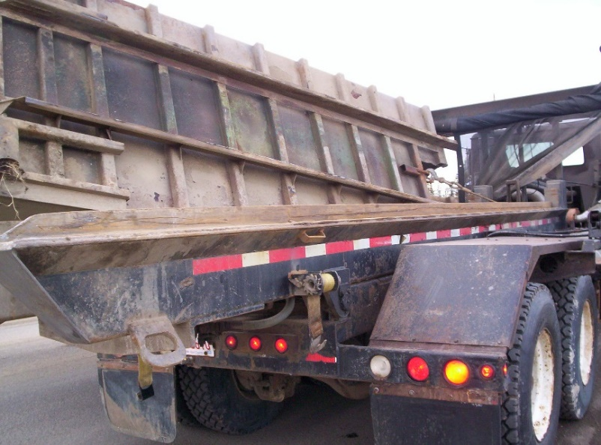In both the U.S and Canada, the regulation/standard does not specify how the securement is to be accomplished so the industry has designed several different types, but they all prevent forward, rearward and upward movement. When an integral securement system is not present, other means of securement are required to prevent the container from becoming dislodged or moving to the extent that the vehicle’s stability and maneuverability is adversely affected.

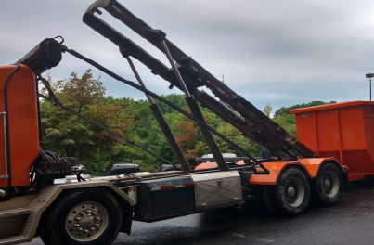**Roll-On/Roll-Off Container**

Figure 1

This type of container is installed on the carrier

truck or on the semi-trailer (hereinafter called “the vehicle”) with a cable that pulls it on a tilt bed. Trucks designed for transporting Roll-On/Roll-Off containers can transport containers of different lengths made by various manufacturers (see Figure 1).

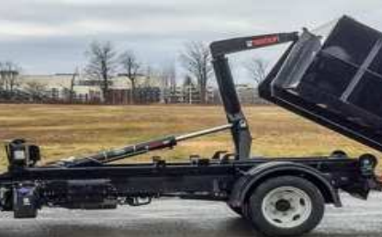**Hook Lift Container**

Figure 2

This type of container is installed with an articulated arm that pulls it and deposits it directly on the fixed side rails of the vehicle. Normally, Hook Lift containers must be transported only with a vehicle specifically designed for this purpose. Usually, the container and the vehicle’s cargo securement system come from the same manufacturer (see Figure 2).

***Integral Securement Systems***

The American National Standards Institute (ANSI) Standard 7.3.4.3 outlines that the integral securement system must meet all the following conditions:

* All the securement devices on the container must mate with the receiving devices on the vehicle frame and allow no more than 2 3/4” ( 7 cm) movement in any direction.
* 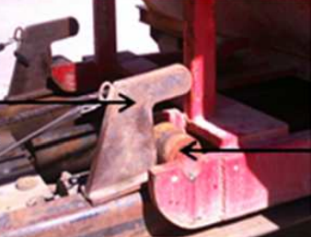The mating of the securement devices at the front of the container are devised of fixed hooks on the frame to prevent upward and forward movement when the container is pulled into the transit position by the cable winch (e.g., normally “C” hooks). The system also includes stops on the front of the container which must be aligned directly under the vehicle’s hooks as shown in Figure 3.

Hook

Stop

Figure 3

Internal rail integral device

External rail integral device

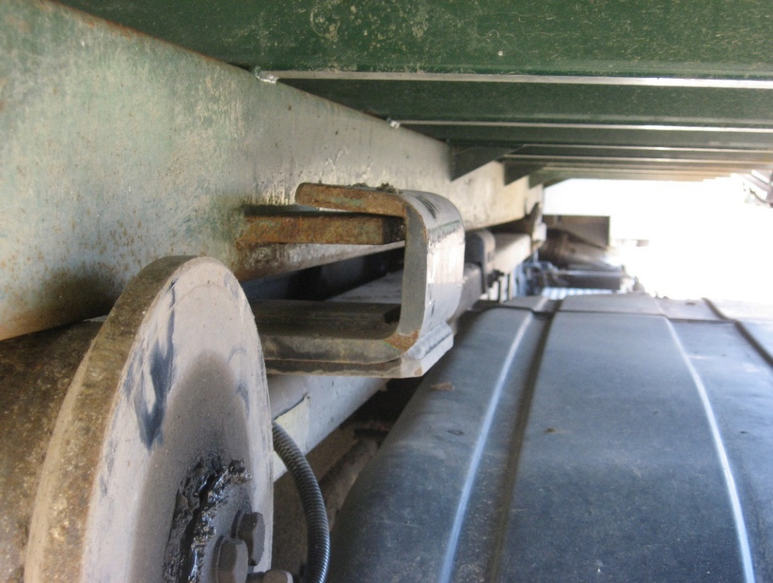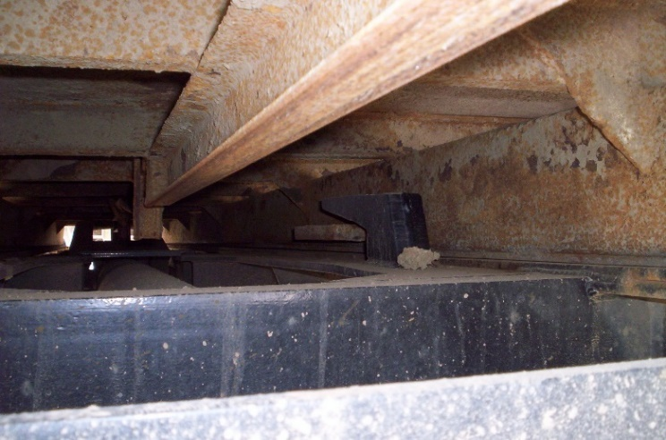

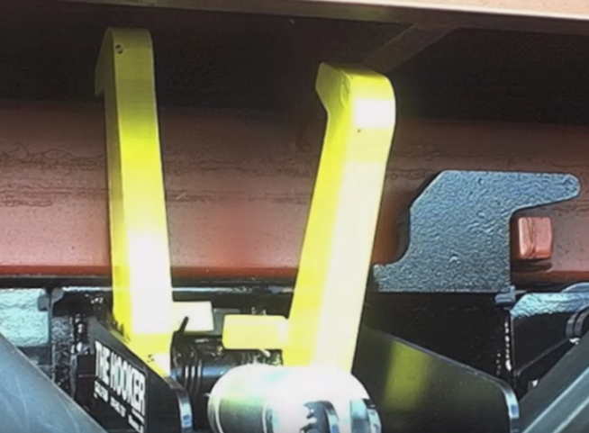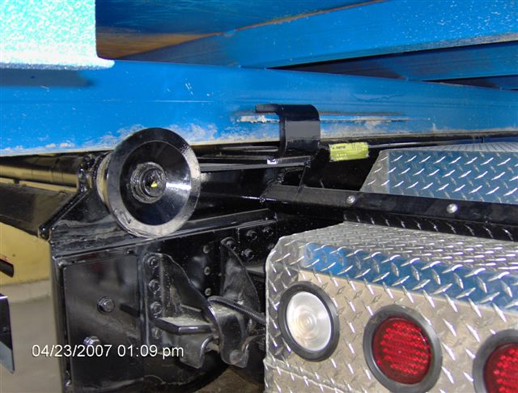

External rail integral device

External rail integral device

***Examples of the integral locking device on the container mated with lock down bracket on the vehicle.***

* The hook or other lifting feature which attaches the container to the vehicle must be designed to:
  + Prevent the container from becoming accidentally disengaged during transport
  + Prevent rearward movement of the container, or have an additional device engaged for over the road transit to prevent rearward movement of the container.
* The mating of the long rails of the frame and container within one another must provide adequate side to side restraint for the movement of the container.
* A single hook type device may be part of an integral is enough if it is located at the center between the rails, but at least two hooks are necessary (one on each side) if they are located on the side rails (see above picture).

There is no requirement as to the type of device that is used or the location of the devices providing they meet the above conditions. Industry has developed several different types of systems that meet the requirements. Providing the mating system is present and mated along the rails and at the front, the system is compliant.

***Without Integral Securement Systems***

§393.134 and NSC Standard 10, Part II, Division 8 provide for an alternate means of securement when the vehicle or the container are not equipped with an integral locking system.

The container must be:

* Blocked against forward movement by the lifting device (winch or other means), stops, or a combination of both or other suitable restraint mechanism
* Secured to the front of the vehicle by the lifting device or other suitable restraint against lateral and vertical movement
* 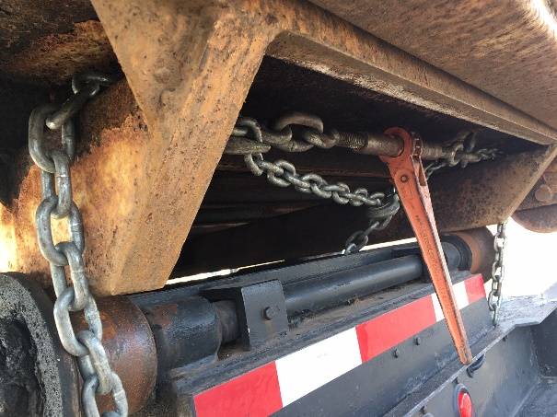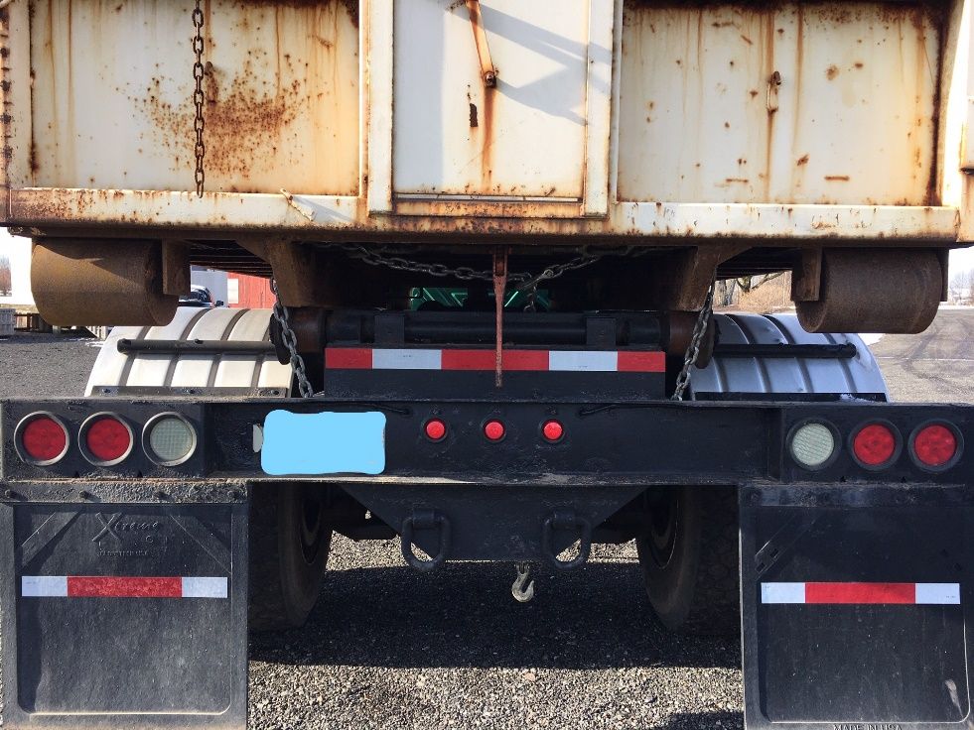Secured to the rear of the vehicle with at least one of the following mechanisms:

Rear of Roll-on/Roll Off Container

* + 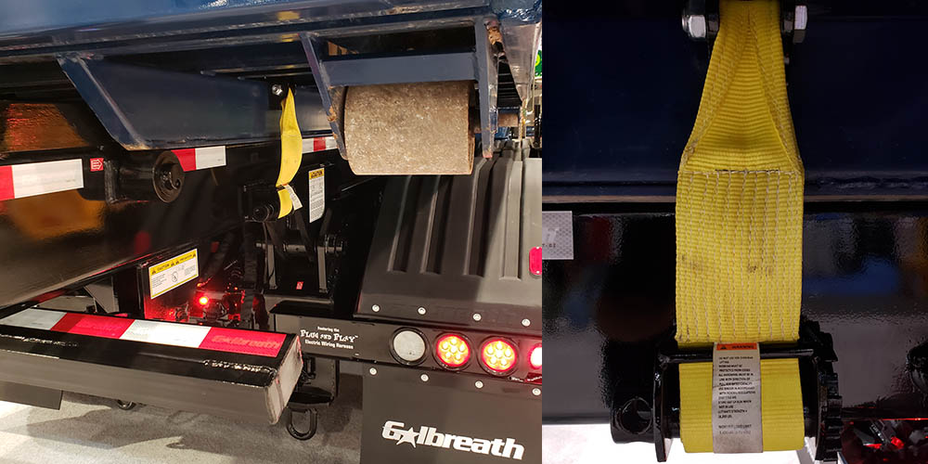One tiedown with a tensioning device securing the container to both sides of the chassis by going over or through the container and around the vehicle chassis; or

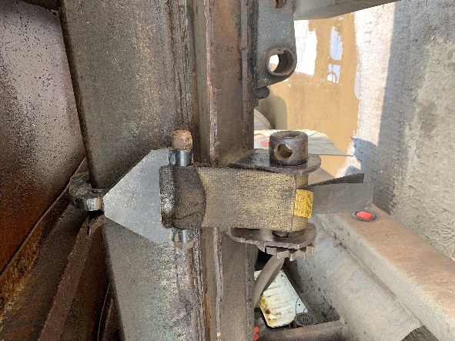

Rear of Roll-on/Roll Off Container

* Two hooks, or an equivalent mechanism, securing both sides of the container to the vehicle chassis at least as effectively as the other two methods above.
* Another uncommon method is two tiedowns installed lengthwise, each securing one side of the container to one of the vehicle's side rails.
* If the system is not an integral locking device, the mechanisms used to secure the **rear end** of a roll-on/roll off or hook lift container must be installed no more than two meters (6 ft 7 in) from the rear of the container.

If one or more of the front stops or lifting devices are missing, damaged or not compatible, additional manually installed tiedowns must be used to secure the container to the vehicle, providing the same level of securement as the missing, damaged or incompatible components.

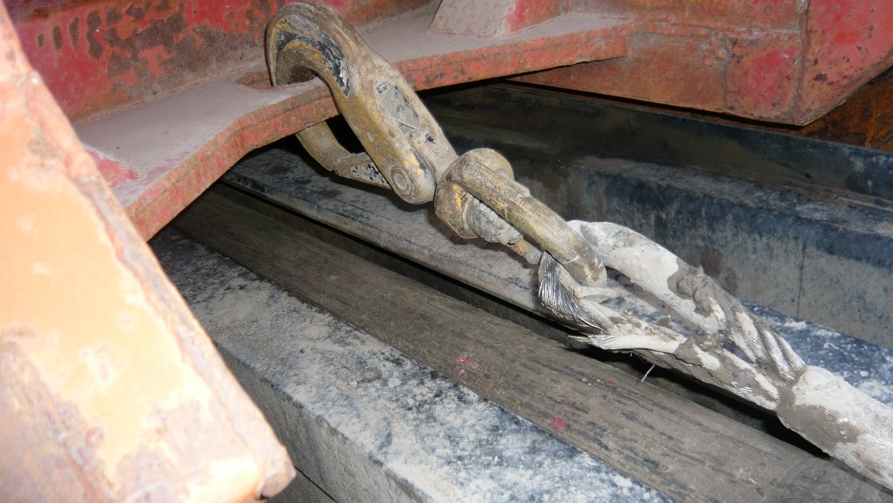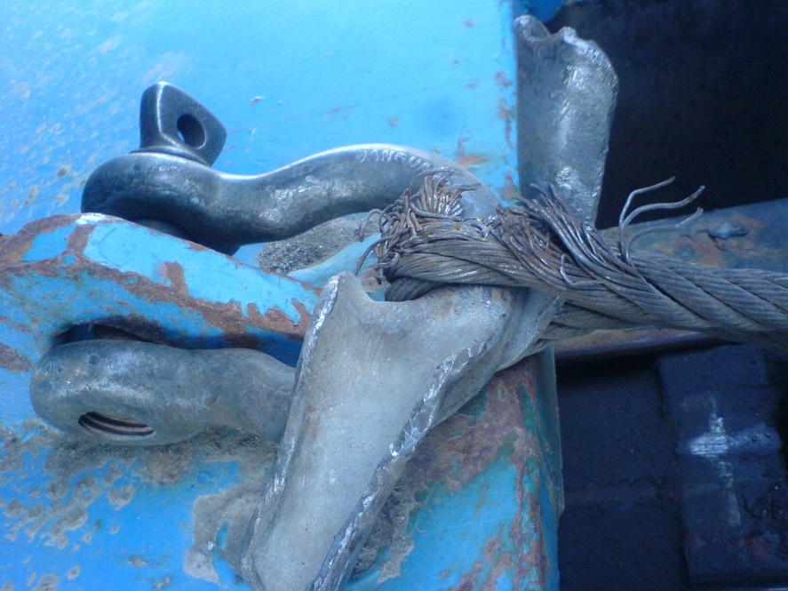

Front of Roll-on/Roll Off Container

(frayed winch cable)

Front of Roll-on/Roll Off Container

(damaged cable connection)

**Lugger Containers on Vehicles**

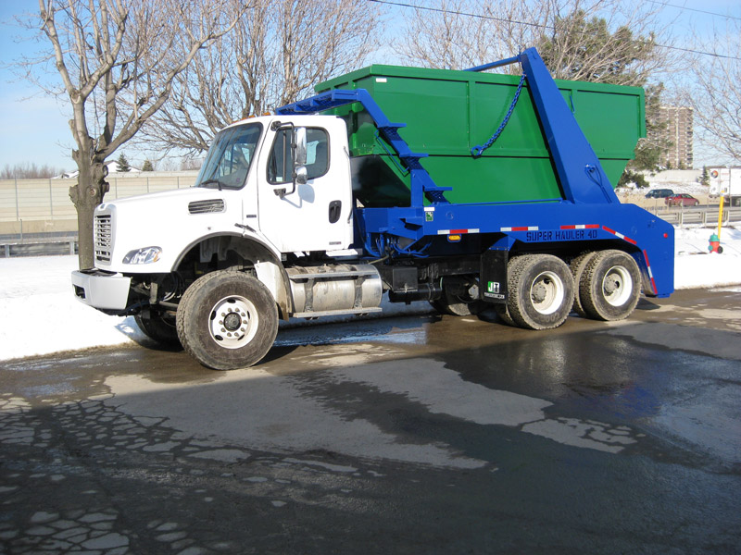Lugger container vehicles do not have an integral securement system. They are designed to pick up the box and transport it on a flat deck of the truck and/or trailer. The chains and hydraulic pins are not part of the cargo securement system, they are used in the loading, offloading and tipping of the box. These containers must be secured as per the general commodity requirements.

The box must be secured for length and weight and requires the number of tiedowns to satisfy both requirements (e.g., one tiedown for every 10 feet or portion thereof plus an additional tiedown in the first 10 feet if not against a front end structure; the aggregate working load limit of the tiedowns must meet half the weight of the container and load). Lugger box securement should be at fixed longitudinal mid-section between the lugs on the side of the lugger container. Any method is acceptable, but this may be achieved by using a tightening device (chains or straps) connected directly to the sides or top of the container. The tightening device shall be anchored to the vehicle on the other end.

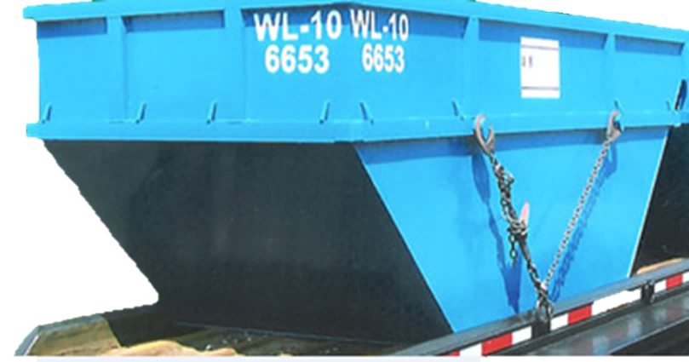

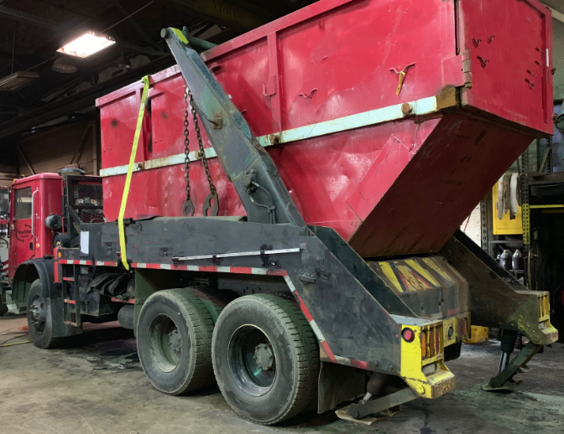

Tiedowns secured to the sides on both sides

Tiedowns secured to the top on both sides

**Guidance**

**Roll-On/Roll-Off Container and Hook-lift Container**

When inspecting roll-on/roll-off and hook-lift containers equipped with integral securement systems, ensure that the system is not damaged and that it prevents movement at the front and the rear.

For those vehicles that **do not** have an integral securement system or parts of the system are damaged, tiedowns must meet the requirements outlined in the U.S. Federal Regulations (§393.134) and Canadian National Safety Code (NSC) Standard 10 (Part II, Division 8).

**Lugger Containers**

When inspecting lugger containers mounted on vehicles, ensure that the container is tied down as per the general commodity requirements for weight and length in the U.S. Regulation and/or NSC Standard.